LUCKNOW PUBLIC SCHOOL

(C. P. SINGH FOUNDATION)



Project Report

*Informatics Practices(065)*

(Session: 2023-24)

Student Name : Tasmay Chawla

Class : XII

Section : B

Roll No. :

CERTIFICATE

name : class/sec :  
roll no : Exam Name: Aissce

XII-B

TASMAY CHAWLA

This is to certify that content of this project

***Bike Showroom Management***

by

***Tasmay Chawla***

is the bonafide work of him/her submitted to

***Lucknow Public School, Jankipuram***

for consideration in the partial accomplishment of the provision of CBSE,

for the award of

***All India Senior Secondary Certificate Examination***

in

***Informatics Practices -065***

the ORIGINAL RESEARCH work was carried out by him/her under my supervision in the academic year 2023-24. on the basis of the declaration made by him/her, I recommended the project report for evaluation.

examiner’s signature teacher in-charge

principal

date stamp

ACKNOWLEDGEMENT

I take this opportunity with great pleasure and respect to express my first and foremost thanks to the principal,

“**Mrs. Shabnam Singh”**

for her encouragement and for the facilities that she provided for this project work. I extend my hearty thanks to

**“Mr. Abhay Pratap Singh”**

Informatics Practices Teacher who guided me throughout the successful completion of this project. I take this opportunity to express my deep sense of gratitude for his guidance, constant encouragement, immense motivation, which has sustained my efforts at all the stages of thisproject.

I can’t forget to offer my sincere thanks to the parents and to also my classmates who helped me to carry out this project work successfully and for their valuable advice and support, which I received from time to time.

**CONTENT**

* INTRODUCTION
* SOFTWARE & HARDWARE REQUIREMENT
* SOURCE CODE IN PYTHON
* OUTPUT SCREEN
* BIBLIOGRAPHY

**INTRODUCTION**

This project aims to create a user-friendly and simple **“MEDICAL STORE MANAGEMENT SYSTEM”**

in which it allows the user to purchase a vehicle and the system enters its record in the database along with the previously stored data and allows user to receive the bill for their respective purchases.

The system is created by using the following technologies:

* **Python** – A general purpose programming laguage which is popular around the world and is easy to learn and use.
* **Pandas** – A Python library used for data management and manipulation
* **CSV(Comma Separated Values)** – A file format used to store data.

**SOFTWARE AND HARDWARE**

**REQUIREMENT**

**Software Specification: -**

**Operating system:** Windows 7 or above

**Platform:** Python IDLE 3.10 or above

**Languages:** Python

**Hardware specification: -**

**Processor:** Dual core or above

**Hard Disk:** 40 GB

**RAM:** 2 GB

**Note:**

Please install the following libraries before running the program:

* Pandas

**SOURCE CODE**

import pandas as pd

from datetime import datetime

dfSELL=pd.read_csv('D:\\tasmay\\tasmaySELL.csv',index_col='MedID')

dfPRC=pd.read_csv('D:\\tasmay\\tasmayPRC.csv',index_col='NID')

def tsmyMS():

    print('==================================TASMAY_MEDICAL_STORE==================================')

        print('''

          1) View Inventory

          2) Purchase Medicine

          3) View Purchase History

          ''')

        choice = input('Enter Your Choice.')

        if choice == '1':

print('==================================INVENTORY==================================')

          print(dfSELL)

            print('==============================================================================')

        elif choice == '2':

print('==============================PURCHASE_MEDICINE===============================')

        name = input("Enter your Name:")

            while name.isalpha() == False:

                print('Enter a valid name')

                name = input("Enter your Name:")

            nID = name[0:3] + str(datetime.now().strftime('%H%M'))

            print(dfSELL)

            net = 0

            n = int(input('Enter number of items to purchase.'))

            idls = []

            mednamels = []

            qtyls = []

            amtls = []

            for i in range(n):

                id = input('Enter MedID: ')

                qty = input('Enter Quantity: ')

                while id not in list(dfSELL.index) or qty.isnumeric() == False:

                    print('Enter Valid Details.')

                    id = input('Enter MedID: ')

                    qty = input('Enter Quantity: ')

                qty=int(qty)

                amt = int(dfSELL.at[id,'Price'])*qty

                net += int(amt)

                idls.append(id)

                mednamels.append(dfSELL.loc[id]['MedName'])

                qtyls.append(qty)

                amtls.append(amt)

            dfPRC.loc[nID+str(i)]={'MedID':id,'MedName':dfSELL.loc[id]['MedName'],'Quantity':qty,'Amount':amt,'Date':datetime.now().date()}

dfPRC.to_csv('D:\\tasmay\\tasmayPRC.csv')

            print('Thanks for Purchasing.')

            print('===========================================================================')

            billbool = input('Would you like to receive the BILL for the above purchase?(Answer in Y/N): ').lower()

            while billbool not in ['y','yes','n','no'] == True:

                print('Enter a valid choice.')

                billbool = input(('Would you like to receive the BILL for the above purchase?(Answer in Y/N).')).lower()

            if billbool == 'y' or billbool == 'yes':

                print()

                print()

                print('===============================BILL=====================================')

                print('Date & Time: ',datetime.now().date(),datetime.now().strftime('%H:%M:%S'))

                print('========================================================================')

                dfbill=pd.DataFrame({'MedID':idls,'MedName':mednamels,'Quantity':qtyls,'Amount':amtls})

                print(dfbill)

                print('Your total is: ',net)

            elif billbool == 'n' or billbool == 'no':

                print('Thank You')

        elif choice == '3':

            print(dfPRC)

        else:

            tsmyMS()

X=1

while X==1:

    tsmyMS()

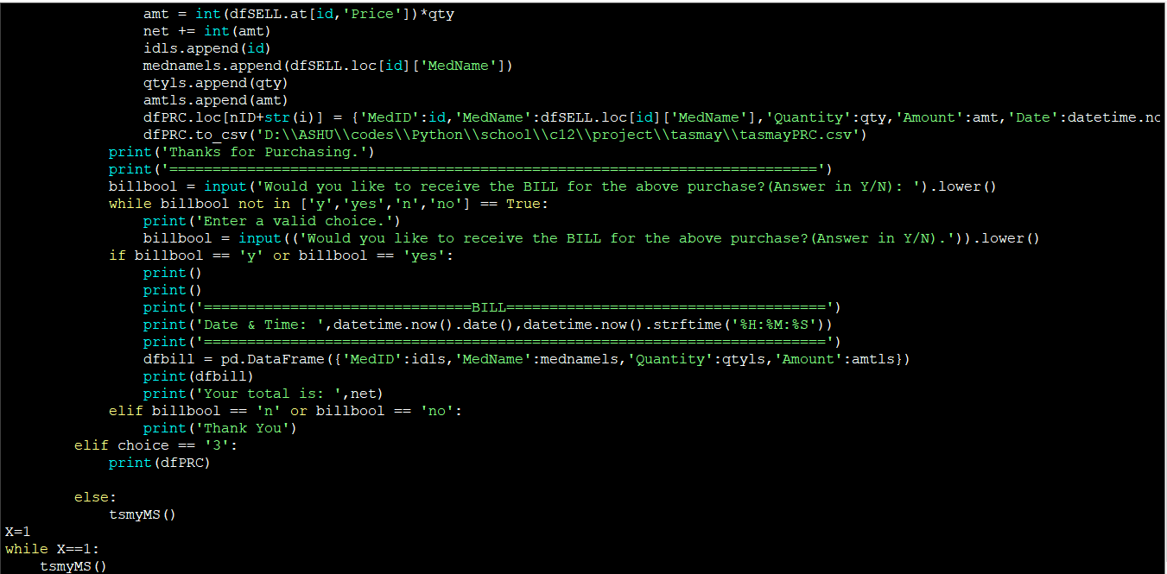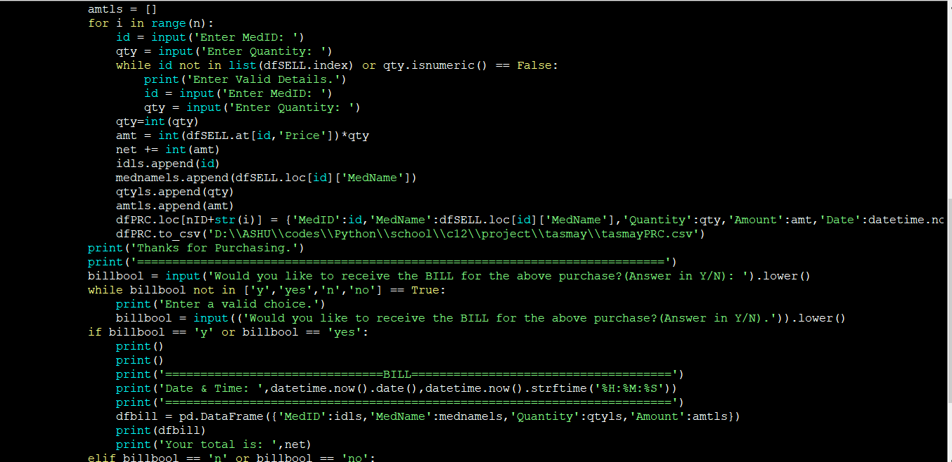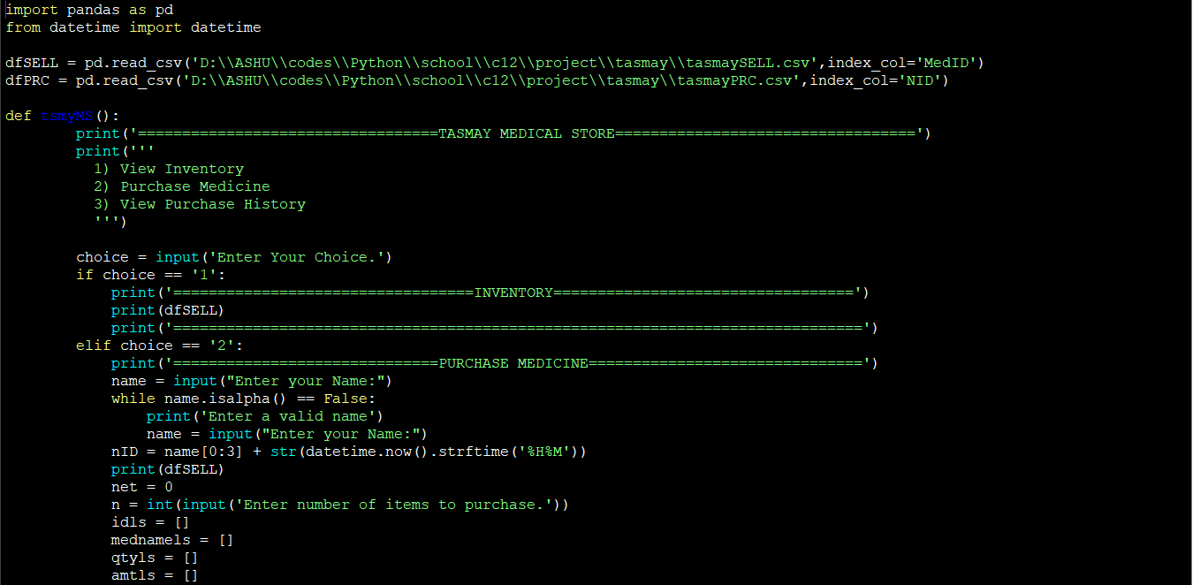

OUTPUT

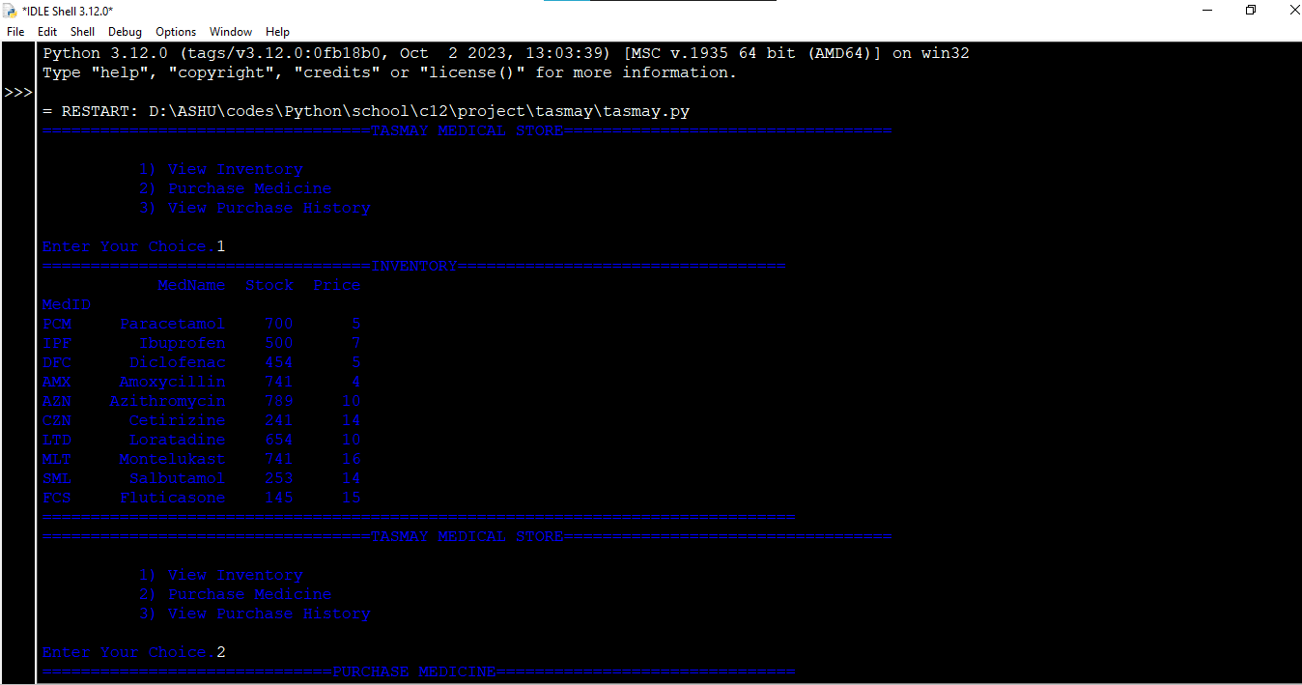

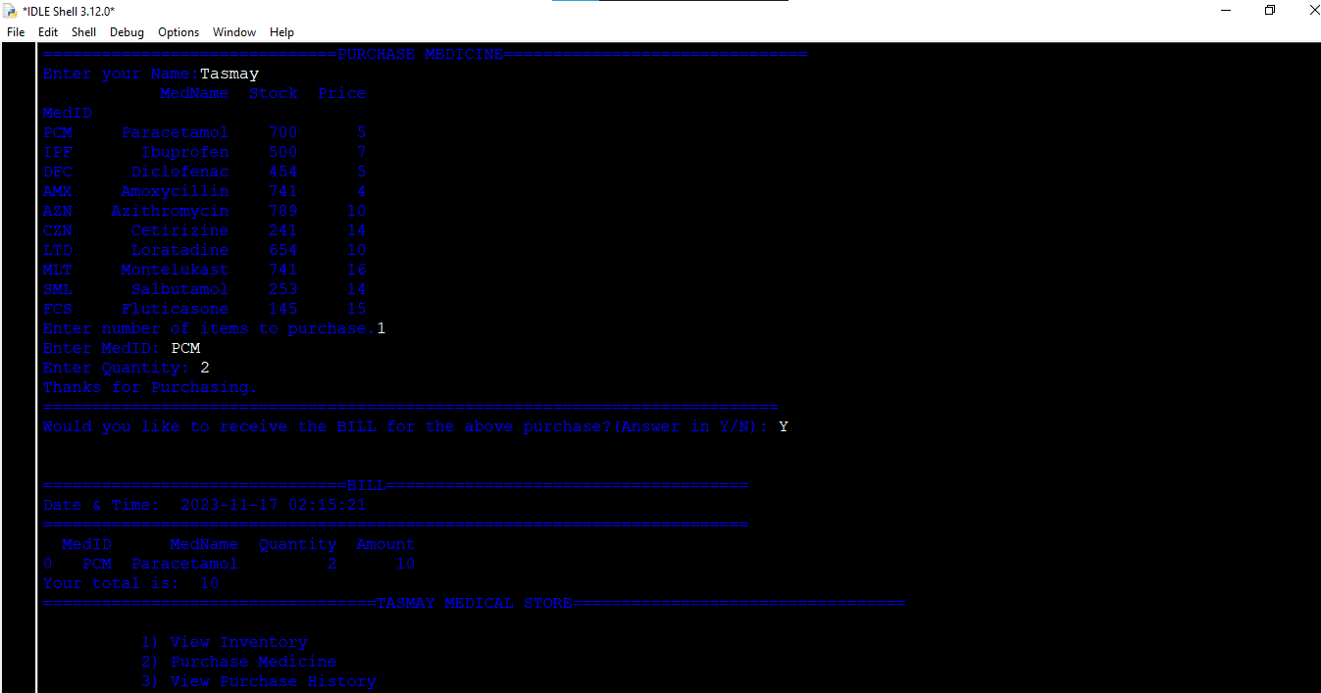

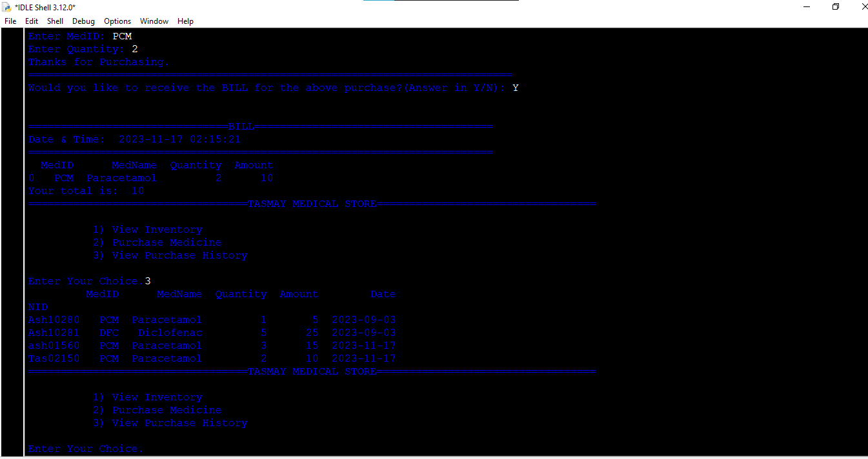

**BIBLIOGRAPHY**

* <https://www.google.com/>
* <https://www.geeksforgeeks.org/python-pandas-dataframe/>
* <https://www.geeksforgeeks.org/python-datetime-module/>